

**~ User Manual ~**

**Brought to you by: *Team #14***

***Farah Amr***

***Hana Amr***

***Kariman Mahmoud***

***Youmna Khaled***

***Update:***

**We’ve loaded our game with a lot of goodies:**

* Bug fixes and performance improvement.
* Enhancement in the speeds of the players.
* Two Players Feature added.
* Chatting mode available.
* Inline chatting available for both players.
* New levels added.
* New power-ups added.

**We update our game regularly so that we can make it more *convenient*, more *reliable*, and *better* for you.**

*Version 2.1.1.*

***New Features:***

1. **Two-Players mode:**

Now, in this update, two players can play the game through two different PCs. Each player would be able to enter his/her username (matching the rules applied to the usernames) from his/her PC (shown in Figure (1)).

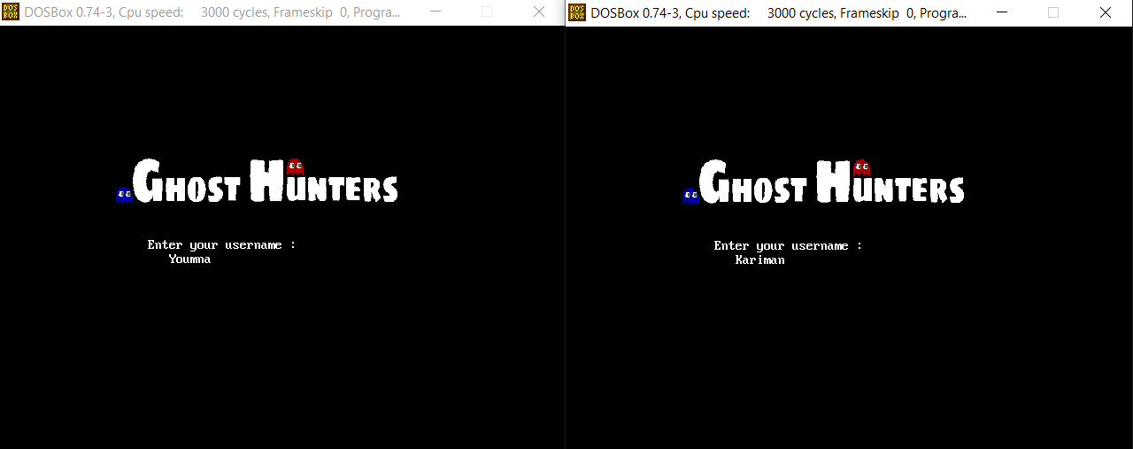

**Figure (1)**

When they both enter their names, each ones name will appear in the other side of the game. This is shown through Figure (2).

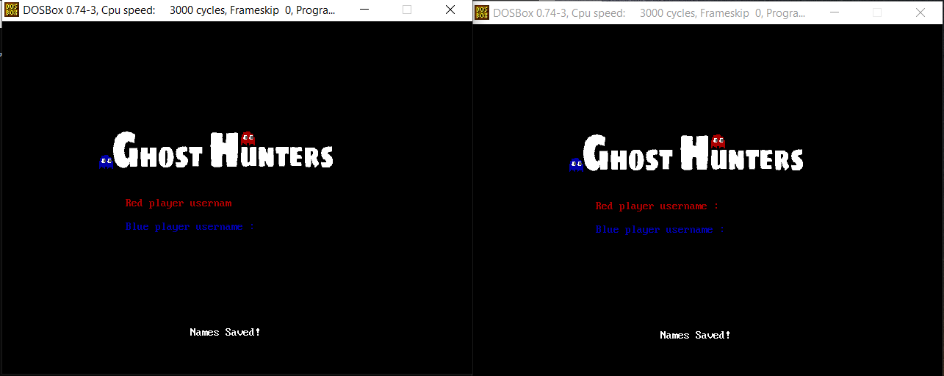

**Figure (2)**

Also, the movement of each player is now with the up arrow, left arrow, right arrow, and left arrow. Also, to be able to change the angles of the bullet, we can now use the “:” and the “ ’ ” keys for directing it.

1. **Chatting Mode:**

When a player chooses “Start Chatting”, he/she sends a chatting invitation to the second player. The Main Menu appears as a welcoming screen with three options:

* Start Chatting.
* Start Playing.
* Exit the game.

The Main menu is shown in Figure (3).

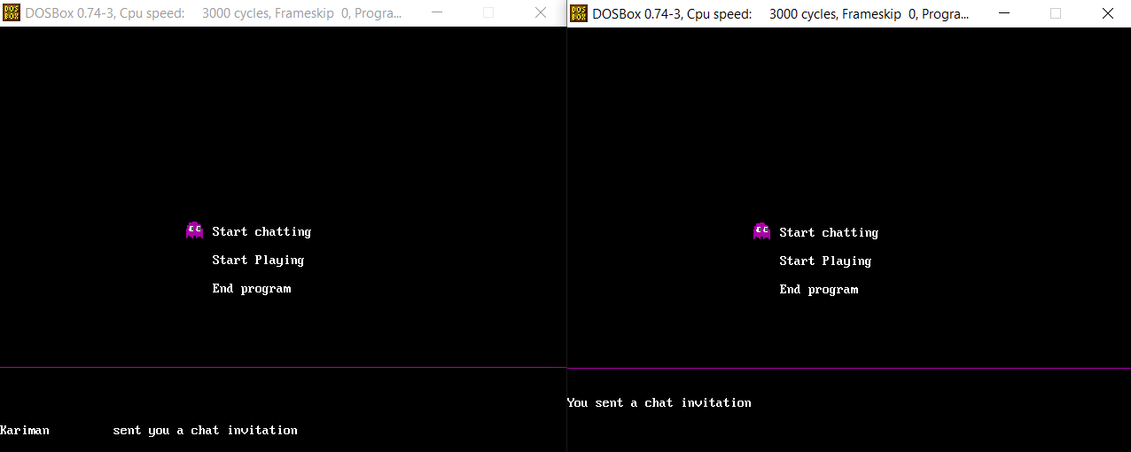

**Figure (3)**

In the chatting process, to illustrate, the second player must choose the same option “Start Chatting” in order to accept this invitation. You can close the Chatting Mode by pressing the “ESC” key. The chatting outline is shown in figure (4):

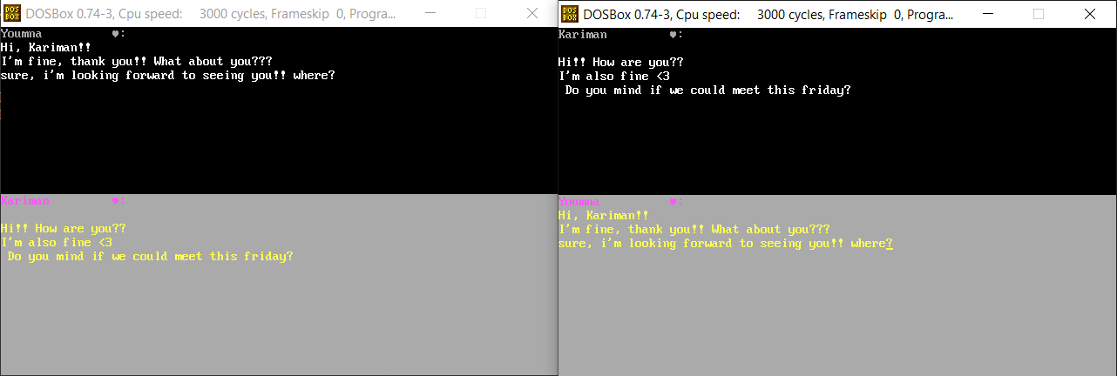

**Figure (4)**

1. **Starting The Game:**

If we’d like to start the game, we must choose the “Start Playing” option from the Main Menu. If you choose this option, then you’ve send an invitation to the other players side of the game, he/she must choose the same option in order actually start the game. This is shown in Figure (5):

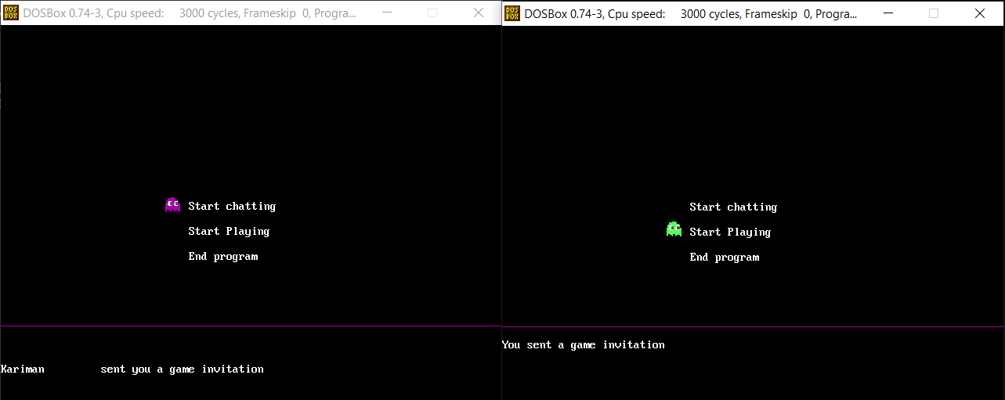

**Figure (5)**

1. **Choosing Game Level:**

The player who sent the invitation is the one who could choose the game level. This is shown in Figure (6):

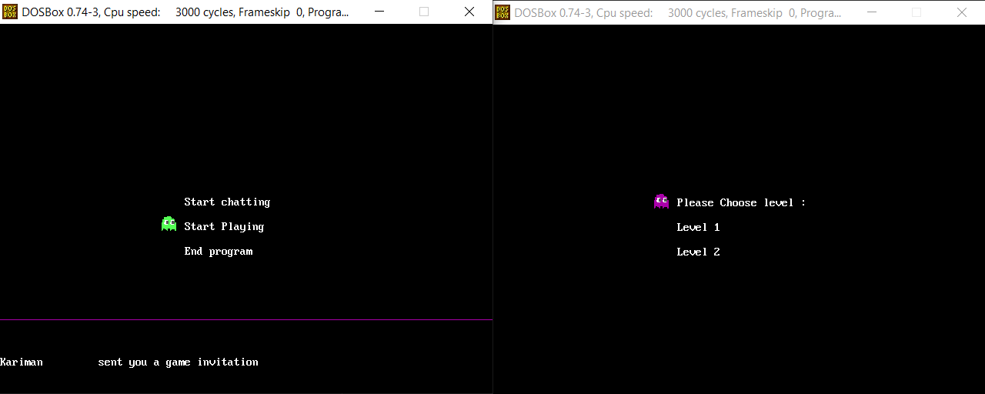

**Figure (6)**

The first level, is the same as the last update. As to remember, the interface is shown if Figure (7):

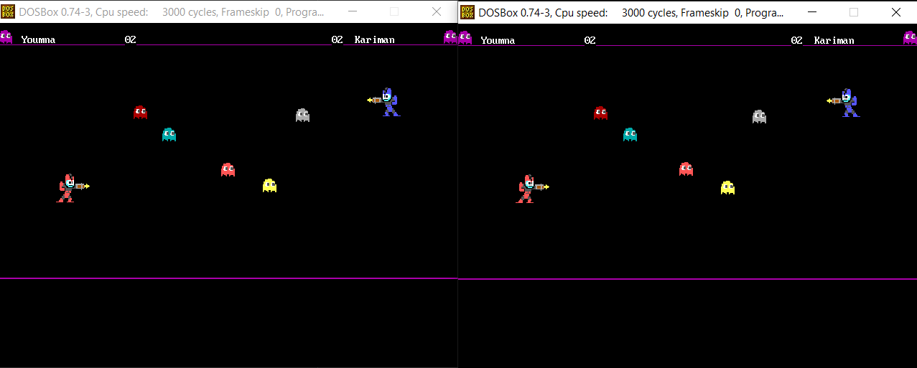

**Figure (7)**

The second level is supported by extra power-ups, and enhancements in the speed of the players.

The Heart Power-Up: This adds extra five points to the player.

The Bomb Power-Up: This resets the score of the opponent to zero.

The modelling of level two can be illustrated in Figure (8):

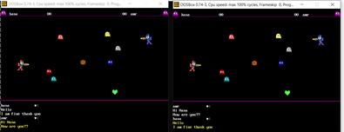

**Figure (8)**

1. **The Inline Chatting:**

While playing, you can also chat with the other player, you can press “P” to start chatting and pause the game. In order to resume, you can press the “ESC” button and continue playing your game peacefully. The inline chatting is shown in Figure (9):

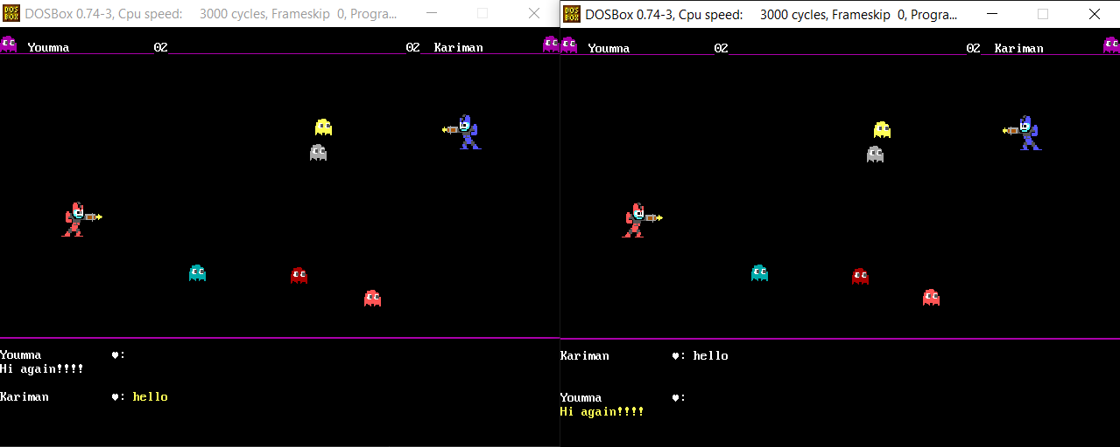

**Figure (9)**

The picture in Figure (10) shows how the game resumes after the resuming it in the inline chat mode**.**

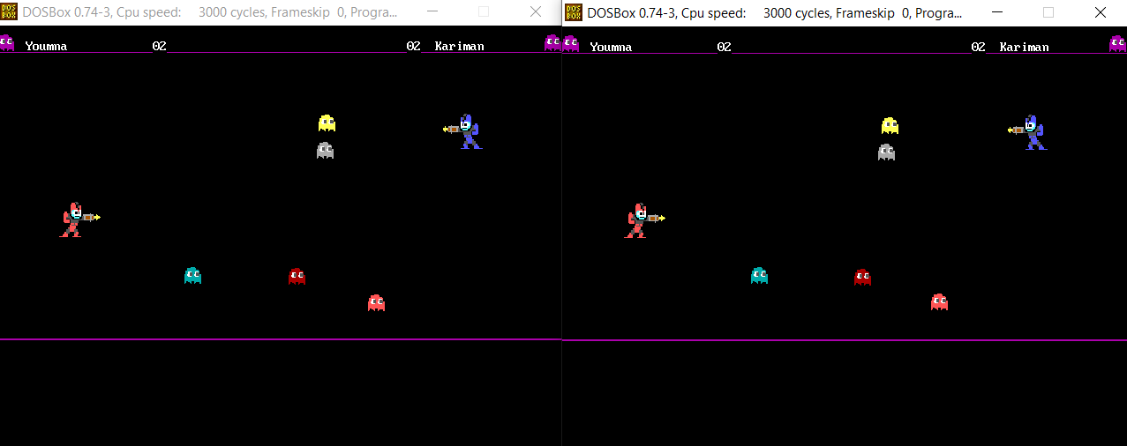

**Figure (10)**

1. **A Brief Description to the Game:**

This is a user manual for our Ghost Hunter game. You will find everything you will need in this game here; the keys used by each user, their functions, and many more interesting things.

This is a two-player game that focuses on the raising the competition between different players. You will be assigned a Red/Blue shooter, and you’ll have to kill the ghosts to gain points.

1. **General Guideline and Policies:**

1. You have to choose a player from two, and write your name in the assigned slot.

2. Your name should not exceed 15 characters of length.

3. Your name shouldn’t start with a special character (i.e. number, @, %, #, $, !, ?, etc..)

4. If any guideline is violated, you will be asked to re-enter your name.

1. **Game Rules:**

1. If you shoot a ghost of your color, you will take two points.

2. If you shoot a ghost of your opposite color, the other player will lose two points.

3. If you shoot any other ghost than the blue and red ones, you will gain a point for each ghost.

1. **The Start-Up Menu:**

***3.1. Start Chatting:***

This feature will be implemented in Phase (2) where two players on different computers can send and receive messages throughout the game.

***3.2. Start Playing:***

This is the beginning of fun! You will start getting into the game and assigning yourself a player along with the other player, and will start the game.

***3.3. End Program:***

This will make you exit from the game, and we will sadly see you leave.

1. **The Game Interface:**
2. ***The Blue Player:***
   1. *Movement:*
      1. Up arrow used for moving upwards.
      2. Down arrow used for moving downwards.
      3. Left arrow used for moving to the left side.
      4. Right arrow used for moving to the right side.
   2. *Shooting:*
      1. The “;” key used to change the direction of the gun upwards.
      2. The “>” key used to change the direction of the gun downwards.
3. ***The Red Player:***

*2.1. Movement:*

1.1.1. “W” key used for moving upwards.

1.1.2. “S” key arrow used for moving downwards.

1.1.3. “D” key used for moving to the left side.

1.1.4. “A” key used for moving to the right side.

* 1. *Shooting:*
     1. The “T” key used to change the direction of the gun upwards.
     2. The “F” key used to change the direction of the gun downwards.

1. ***The Notification Bar:***

This bar is at the lower most region of the screen, and it is used to display messages to the user. This notification bar will be used effectively in Phase (2).

1. ***The Score Bar:***

This bar is at the upper most region of the screen, and it is used to display the score of each player at his/her side of the screen.

1. **How to Win?**

You will win if you score 20 points, and you will be congratulated, and your victory will be celebrated! So in order to win faster, you must concentrate on the ghosts colors that you will shoot in order to make the best out of the game rules.